STEREO HEADSET
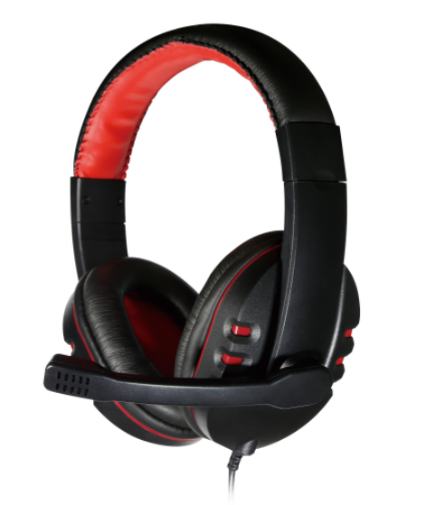
CP-H767

Descrption:
The CP-H767 is a featured, over-the-head Stereo Headphone system using our ClearSound™ audio technology to give great audio feedback no matter what audio applications, and is the perfect partner for Business, MP3 or for just creating an exciting sound experience for the latest Games.

The CP-H767 comes with large, cushioned ear cups attached to durable ergonomic adjustable headband designed to provide comfort during extended use.

With its built-in adjustable Microphone for VoIP applications like Skype®, this premium Stereo Headset provides great performance coupled with great value.

Weighing in at 235g the CP-H767 is perfect headset for everyday business or personal use.

FEATURES
  - Bluetooth(tm) Version 5.0 - Up to 10m range
  - Bluetooth(tm) Profiles - A2DP1.2, AVRCP 1.4, HFP1.6
  - Driver Units - 40mm Dynamode Drivers for clarity
  - Impedance - 32 Ohms +/- 15%
  - Frequency Range - 8Hz to 24Khz Sensitivity 121 +/- 3dB
  - On-board control buttons with MP3 playback
  - Stylish and comfortable over-head design
  - Battery Life - Up to 14 Hours (depending on usage)

.SPECIFICATIONS:
HEADSET
  - Frequency Range：20Hz-20KHz
  - Impedance ：32 0hm
  - Maximum Power Input：100mw
  - Sensitivity：105dB S.P.L. at 1KHz+/-2%
  - Plugging：3.5mm Stereo
MICROPHONE
  - Frequency Range：16Hz-20KHz
  - Impedance ：2.0K 0hm
  - Maximum Power Input：0.4ma
  - Sensitivity：- 54dB±3dB
  - Plugging：3.5mm

